# File permissions in Linux

## Project description

The research team at my organization needs to update the file permissions for certain files and

directories within the projects directory. The permissions do not currently reflect the level of

authorization that should be given. Checking and updating these permissions will help keep

their system secure. To complete this task, I performed the following tasks:

## Check file and directory details

To see the list of files and directories with their permissions, we used the **ls -l** command.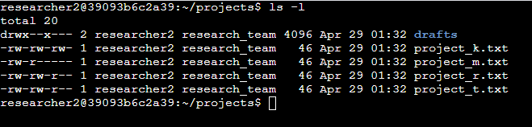

## Describe the permissions string

The permission string in Linux is represented by a 10-character string.

**drwxrwxrwx**

The first character represents the file type. The 2nd to 4th characters are the permissions given to **user**, the 5th to 7th characters are the permissions given to **group**, and the last 3 characters are the permissions given to **others.**

There are 3 types of owners:

* **user:** the owner of the file
* **group:** a larger group that the owner is a part of
* **other:** all other users on the system

The permissions include:

* **Read** (represented by **r**): for files(**-**), this is the ability to read the file contents; for directories(**d**), this is the ability to read all contents in the directory
* **Write** (represented by **w**): for files(**-**), this is the ability to make modifications on the file contents; for directories(**d**), this is the ability to create new files in the directory.
* **Execute** (represented by **x**): for files(**-**), this is the ability to execute the file if it’s a program; for directories(**d**), this is the ability to enter the directory and access its files.

## Change file permissions

To change file permissions, we use the **chmod** command. The **chmod** command has 2 arguments, the first argument indicates how to change permissions, and the second argument indicates the file or directory that you want to change permissions for.

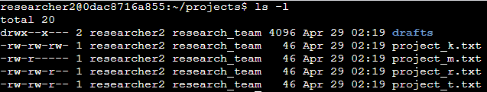

In this example, we will add **execute** permission to **user** and remove **write** permission to **group and other** in the **project_k.txt** file.

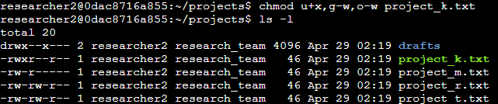

## Change file permissions on a hidden file

To view hidden files, we can use **ls -la**

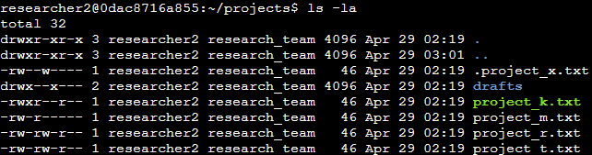

And to change the permissions, we can use **chmod**

## Change directory permissions

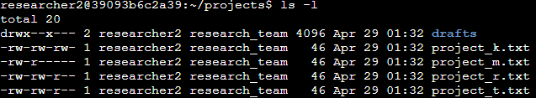

In this example, we want to change the permissions of the **drafts** directory to remove the **execute** permission from the **group**.



So by using **chmod g-x drafts,** we removed the **execute** permissions from the group

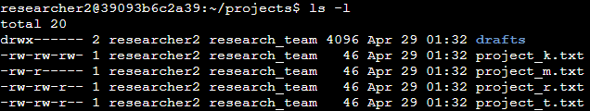

We can also change the permissions of other owners by using a **comma**(**,**) on the first argument.

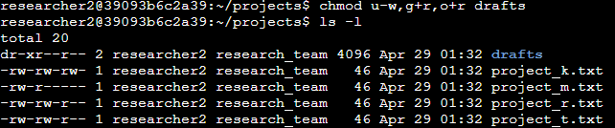

In this example, we removed the write permission from **user** and added read permissions to the group and **others**.

You can also use **equal(=)** sign to assign permissions.

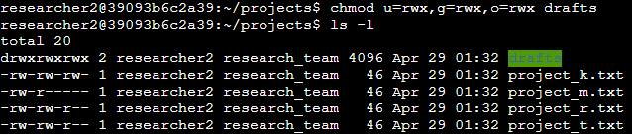

## Summary

Managing directory and file permissions is a part of the work of a security analyst. Using **ls** with the **-l**  and **-la** options allows us to investigate directory and file permissions. Using **chmod** allows us to change user permissions and ensure they are aligned with the principle of least privilege.